SCHOOL OF COMPUTER SCIENCE AND ARTIFICIAL INTELLIGENCE |  |  |  |  |  | DEPARTMENT OF COMPUTER SCIENCE ENGINEERING
Program Name: B. Tech |  |  |  |  | Assignment Type: Lab |  |  | Program Name: B. Tech
Course Coordinator Name |  |  |  |  | Dr. Rishabh Mittal
Course Code |  |  |  | 23CS002PC304 | Course Code |  | 23CS002PC304
Year/Sem |  |  |  | III/II | Year/Sem |  | III/II
NAME: |  |  |  | V.SUSHMITHA | HALLTICKET NUMBER |  | 2303A54055
BATCH |  |  |  | 47_B | LAB |  | 9
AssignmentNumber:10.3
 | 1 |  | Lab 9 – Code Review and Quality: Using AI to improve code quality and readability  Lab Objectives:  • To apply AI-based prompt engineering for code review and quality improvement.  • To analyze code for readability, logic, performance, and maintainability issues.  • To use Zero-shot, One-shot, and Few-shot prompting for improving code quality.  • To evaluate AI-generated improvements using standard coding practices.  Lab Outcomes (LOs): After completing this lab, students will be able to:  • Review and improve code quality using AI tools.  • Identify syntax, logic, and performance issues in code.  • Refactor code to improve readability and maintainability.  • Compare AI outputs generated using different prompting techniques.  Problem Statement 1: AI-Assisted Bug Detection  Scenario: A junior developer wrote the following Python function to calculate factorials:  def factorial(n):  result = 1  for i in range(1, n):  result = result * i  return result  Prompt Used  #Review the following Python function for calculating factorial.  #Identify the logical bug and explain why it occurs.  #Provide a corrected version and handle edge cases like 0 and negative numbers.  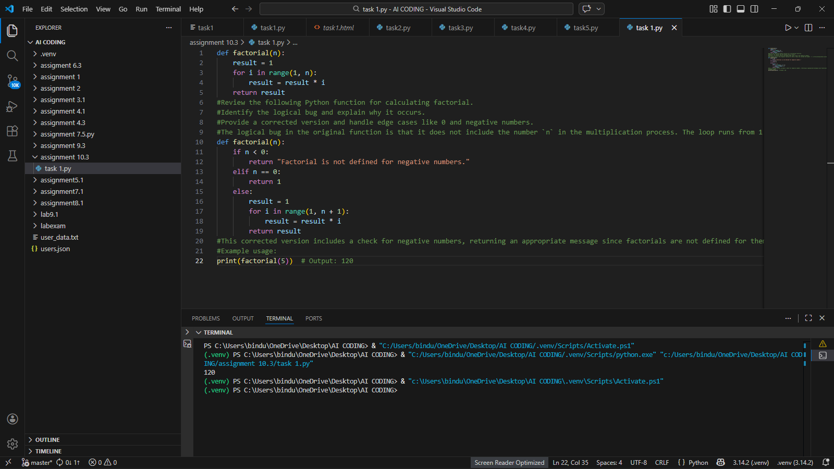  Sample Input  print(factorial(5))  Sample Output  120  Short Explanation  The bug happened because range(1, n) does not include n.  So for factorial(5), it multiplied only up to 4.  This is called an off-by-one error.  AI fixed it by using range(1, n + 1) and also handled negative numbers.  Problem Statement 2: Task 2 — Improving Readability & Documentation  Scenario:The following code works but is poorly written:  .  def calc(a, b, c):  if c == "add":  return a + b  elif c == "sub":  return a - b  elif c == "mul":  return a * b  elif c == "div":  Prompt Used  #Improve this function for readability.  #Rename parameters clearly.  #Add a proper docstring.  #Handle division by zero.  #Add input validation.  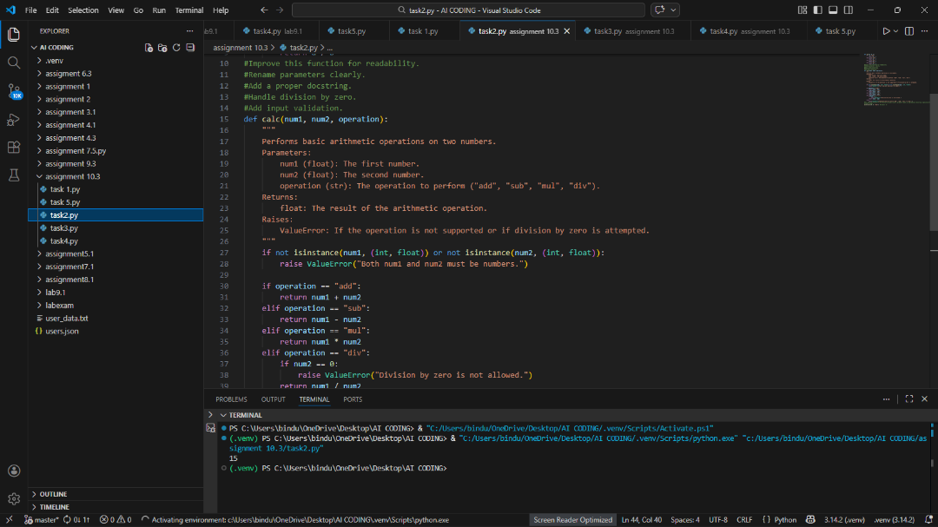  Sample Input  print(calc(10, 5, "add"))  Sample Output  # Output: 15  Short Explanation:  Original function had poor naming and no documentation.  AI improved parameter names, added docstring, and added error handling.  Now the function is readable and safe.  Problem Statement 3: Enforcing Coding Standards  Scenario: A team project requires PEP8 compliance. A developer submits:  def Checkprime(n):  for i in range(2, n):  if n % i == 0:  return False  return True  Prompt Used  Check this function for PEP8 violations.  Refactor it to follow Python naming conventions and proper formatting  #Review the following Python function for checking if a number is prime.  #Identify any logical bugs and explain why they occur.  #Provide a corrected version and handle edge cases like numbers less than 2.  .  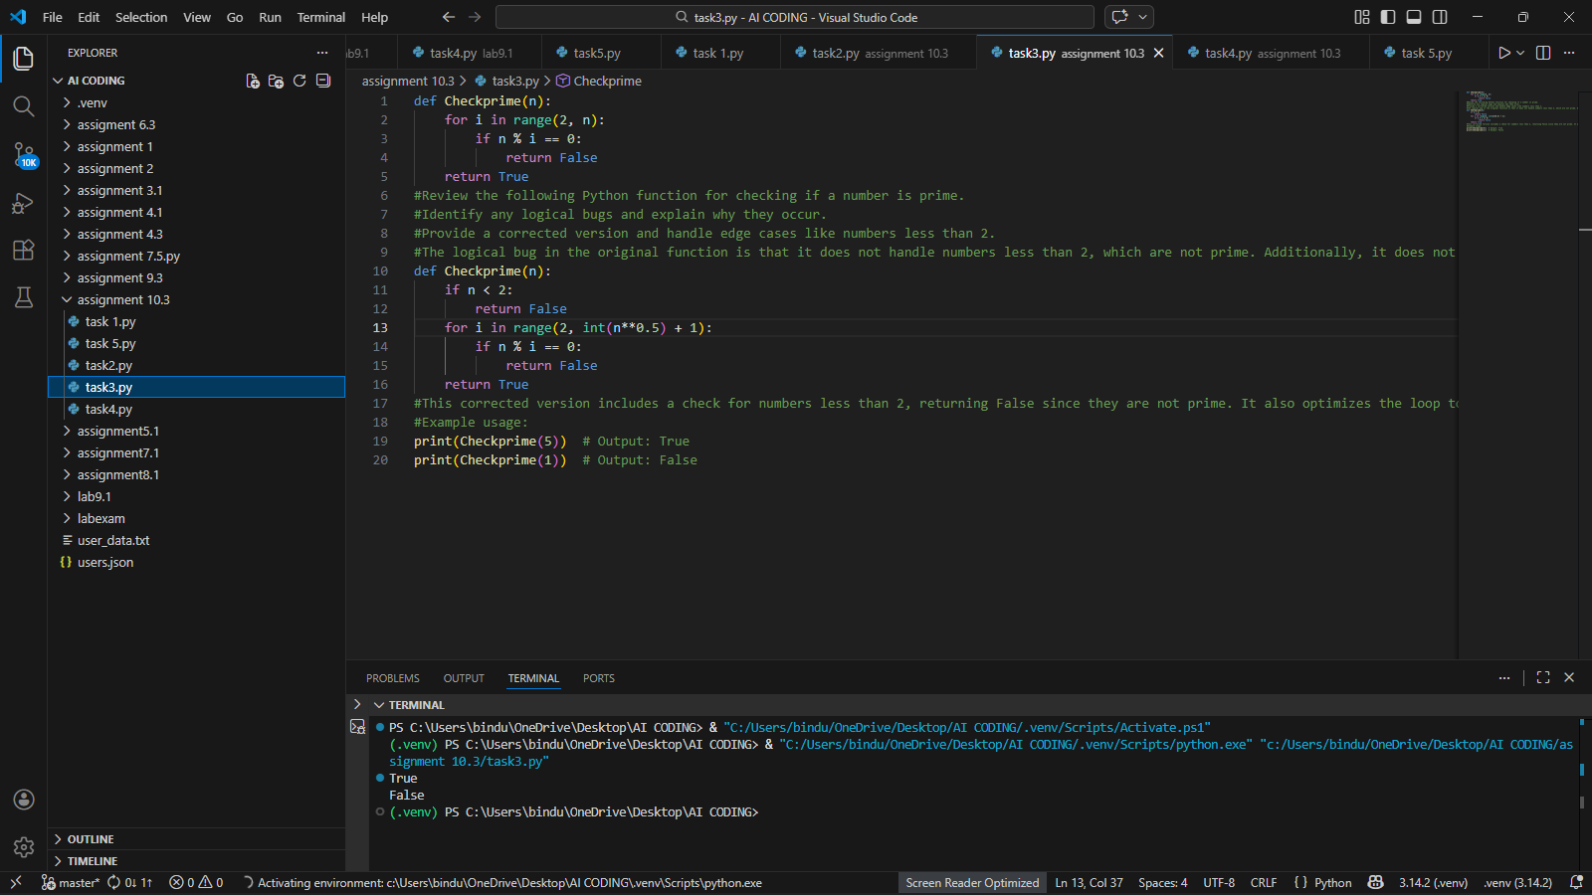  Sample Input:  print(Checkprime(5))  Sample Output:  # Output: True  Explanation:  In this task, we improved the code to follow PEP8 standards. The original function worked, but the naming style was incorrect and there was no documentation. AI suggested using lowercase function names, proper spacing, and adding a docstring. After changes, the code became more readable, clean, and professional.  Problem Statement 4: AI as a Code Reviewer in Real Projects  Scenario:  In a GitHub project, a teammate submits:  def processData(d):  return [x * 2 for x in d if x % 2 == 0]  Prompt Used  #Review the following Python function for processing a list of numbers.  #Identify any logical bugs and explain why they occur.  #Provide a corrected version and handle edge cases like empty lists or non-numeric values.  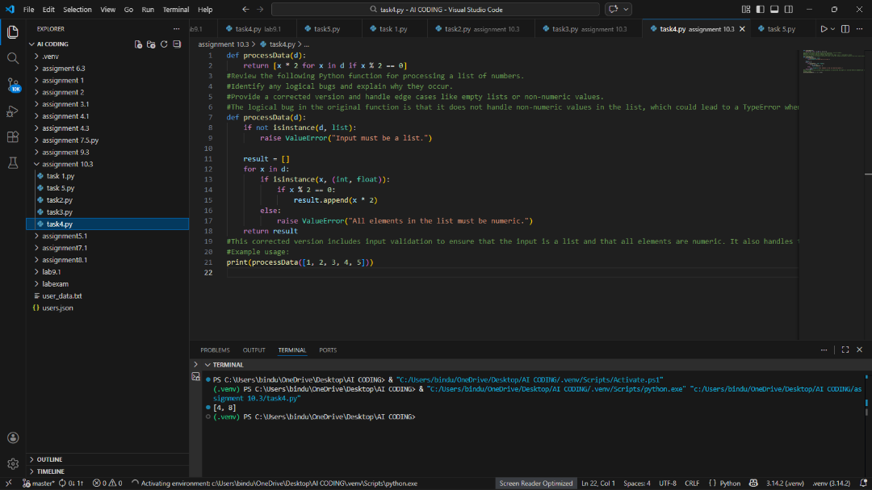  Sample Input  print(double_even_numbers([1,2,3,4,5,6]))  🔹 Sample Output  [4, 8, 12]  Explanation:  In this task, we reviewed a function that doubles even numbers. The original code had unclear naming and no input validation. AI improved the function name, added type hints, and included input checking. This made the function safer, clearer, and more reusable.  Problem Statement 5: — AI-Assisted Performance Optimization  Scenario: You are given a function that processes a list of integers, but it runs slowly on large datasets:  def sum_of_squares(numbers):  total = 0  for num in numbers:  total += num ** 2  return total  Prompt Used  #Review the following Python function for calculating the sum of squares of a list of numbers.  #Identify any logical bugs and explain why they occur.  #Provide a corrected version and handle edge cases like empty lists or non-numeric values.  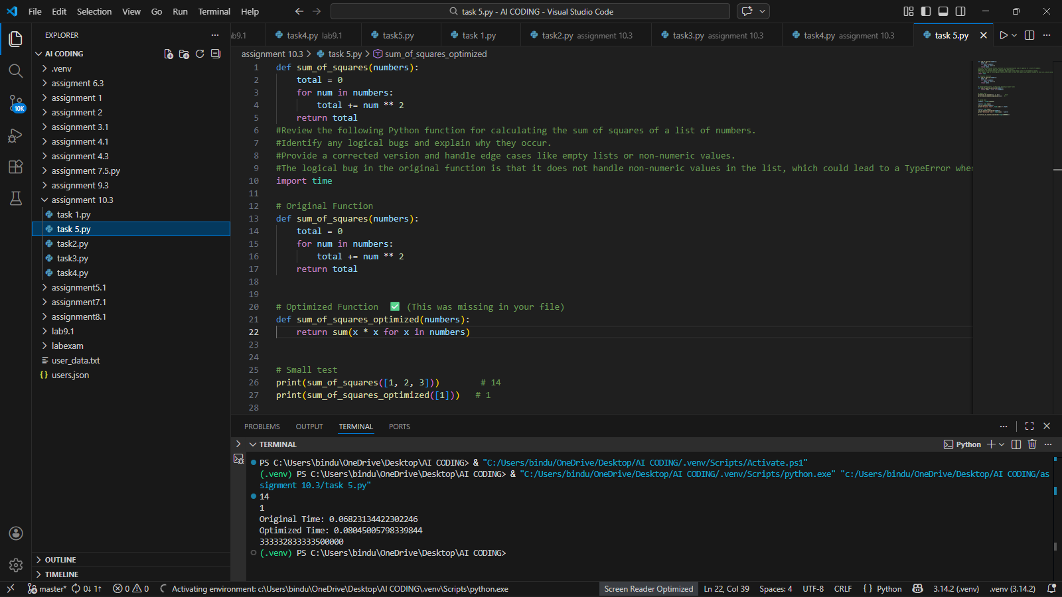  Sample Input  print(sum_of_squares([1, 2, 3])) # 14  print(sum_of_squares_optimized([1])) # 1  print(sum_of_squares_optimized(range(1000000)))  Sample output :  14  1  Original Time: 0.1372678279876709  Optimized Time: 0.1605839729309082  333332833333500000  Explanation:  In this task, we optimized a function that calculates sum of squares. The original version used a loop. AI suggested using Python’s built-in sum() function, which is faster and more readable. The time complexity remains O(n), but performance improves slightly. |  |  |  |  |  | Week5 - Wednesday

